Recessed Spot Light

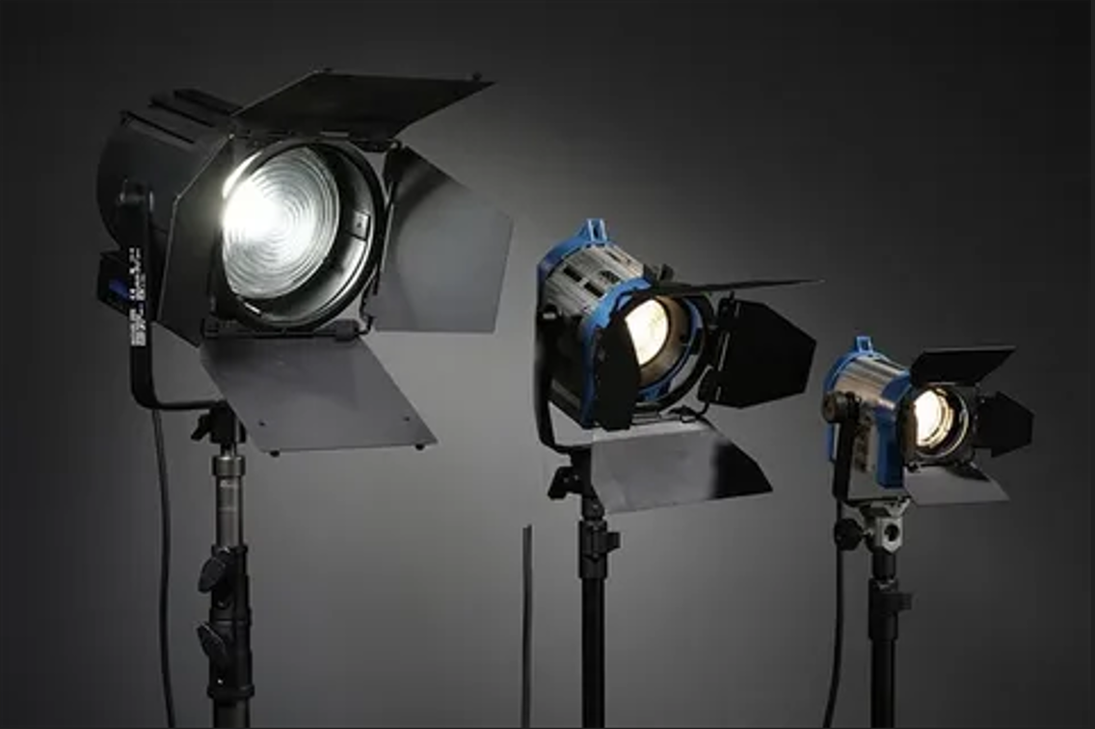

#### ****Description:****

**Recessed Spot Lights** are sleek, energy-efficient lighting solutions designed to be installed flush with the ceiling or wall, providing a clean and modern look. These lights are perfect for highlighting specific areas or objects, such as artwork, architectural features, or retail displays, while maintaining a minimalist aesthetic. With adjustable heads and a variety of color temperatures, Recessed Spot Lights offer both functionality and style.

* **Technology:** LED.
* **Compatibility:** Standard housing for recessed lighting (canless or with housing).
* **Bulb Type:** Integrated LED (non-replaceable).
* **Wattage:** 10W (equivalent to 75W incandescent), 15W (equivalent to 100W incandescent).
* **Lumens:** 800 lumens (10W), 1200 lumens (15W).
* **Color Temperature:** 2700K (warm white), 3000K (soft white), 4000K (cool white).
* **Dimmable:** Yes (select models).
* **Lifespan:** 50,000 hours.
* **Energy Efficiency:** Energy Star certified.
* **Beam Angle:** Adjustable (typically 15° to 60°).

#### ****Key Features:****

* **Sleek and Minimalist:** Installs flush with the ceiling or wall for a clean, modern look.
* **Energy-Efficient:** Uses up to 85% less energy than traditional incandescent bulbs.
* **Focused Lighting:** Ideal for highlighting artwork, architectural features, or retail displays.
* **Dimmable Options:** Available in dimmable models for adjustable brightness.
* **Long Lifespan:** Lasts up to 50,000 hours, reducing the need for frequent replacements.
* **Adjustable Heads:** Allows you to direct light precisely where it’s needed.
* **Easy Installation:** Compatible with standard recessed housing or canless installation.

#### ****Pricing:****

* **Single Recessed Spotlight (10W):** $29.99
* **Single Recessed Spotlight (15W):** $39.99
* **4-Pack (10W):** 99.99(99.99(25.00 per light)
* **4-Pack (15W):** 139.99(139.99(35.00 per light)

#### ****Where to Use:****

* **Living Rooms:** Highlight artwork or architectural features.
* **Kitchens:** Provide task lighting for countertops and workspaces.
* **Retail Stores:** Showcase products with bright, focused lighting.
* **Galleries and Museums:** Accentuate exhibits with precise lighting.
* **Offices:** Enhance productivity with bright, adjustable light.

### ****Customer Reviews:****

* ⭐⭐⭐⭐⭐ "These Recessed Spot Lights are amazing! They provide bright, focused light, and the adjustable heads make it easy to direct the light exactly where I need it." – Sarah L.
* ⭐⭐⭐⭐ "Great value for the price. The lights are bright, and the dimming feature is smooth and reliable. Highly recommend for anyone looking to upgrade their lighting." – James T.
* ⭐⭐⭐⭐⭐ "I love how energy-efficient these spotlights are. The sleek design blends perfectly with my modern decor." – Emily R.

### ****How to Order:****

1. Visit our website: [www.brightworldlighting.com](http://www.brightworldlighting.com/)
2. Select your preferred spotlight type and pack size (Single or 4-Pack).
3. Add to cart and proceed to checkout.
4. Enjoy free shipping on all orders over $100!

### ****Warranty and Support:****

* **Warranty:** 2-year limited warranty covering manufacturing defects.
* **Customer Support:** Contact us at [support@brightworldlighting.com](mailto:support@brightworldlighting.com) or call +1-800-123-4567 for assistance.

### ****Visual Representation:****

Include high-quality images of the Recessed Spot Lights in different settings (e.g., living room, kitchen) to showcase their versatility and design.